RESEARCH PAPER

**STROKES MASTER CRICSHOT ANALYZER AND VISUALIZATION USING POSE ESTIMATION**

**Abstract**

Cricket is one of the most popular and widely followed sports in the world. With the growing popularity of cricket, various countries are taking part in various tournaments and leagues held all over the world. Because each player is expected to give their all, it is critical that they thoroughly understand the game. Recognizing and classifying various batting shots used in cricket plays an important role in the creation of context-based advertisements. It can be used to generate automatic textual commentary. Because each player is expected to give their all, it is critical that they thoroughly understand the game. The goal of this project is to provide athletes and coaches with actionable insights that will lead to continuous improvement in cricketing techniques and strategies.

In the context of cricket, the precision and effectiveness of a cricket shot emerge as pivotal factors that influence a player's performance and the overall outcome of a match. This research aims to introduce an innovative system, named "Strokes Master," designed to revolutionize the in-depth analysis and visualization of cricket shots. The foundation of this system rests on the utilization of cutting-edge pose estimation technology, fundamentally reshaping the way cricket shots are examined and comprehended. In this paper, we embark on a comprehensive exploration of the multifaceted aspects of "Strokes Master," providing a detailed insight into its architectural blueprint, the intricacies associated with data collection, the subtleties of pose estimation techniques, and the novel visualization methodologies it employs. Furthermore, we meticulously present the outcomes of a series of methodical experimental assessments conducted with the system, shedding light on its potential ramifications within the domain of cricket shot analysis

**Index terms:**

* Cricket shot analysis
* Strokes Master system
* Pose estimation technology
* Shot visualization
* Innovative sports technology
* Experimental assessments

**Introduction:**

Cricket Shot Analysis and Visualization using Pose Estimation is not just a basic examination of a player's technique; it is a part of data, algorithms, and athleticism harmonious to redefine how we perceive and understand the art of batting. The insights gained from such analysis can contribute to more marked coaching, personalized training programs, and ultimately, improved performance on the cricket field. Pose estimation involves tracking key points on a person's body, creating a skeletal model that represents their posture and movements. In the context of cricket, pose estimation can be applied to batsmen to capture the differences of their shots, including body positioning, bat angles, and follow-through. In this context, the focus is on analyzing cricket shots, such as the cover drive, pull shot, or straight drive etc.

The process typically involves capturing image or video footage of players during a match or practice session. Advanced computer vision algorithms then analyze this footage, detecting and tracking the positions of key landmarks, including the nose ,Left_eye_inner,Left_eye,Right_eye,Right_eye_outer,Right_eye_inner,Left_ear,Right_ear,Left_mouth,Right_mouth,Left_shoulder,Right_shoulder,Left_elbow_Right_elbow,Left_wrist,Right_wrist,Left_pinky,Right_pinky,Right_index,Left_index,Right_thumb,Left_thumb,Left_hip,Right_hip,Left_knee,Right_knee,Left_ankle,Right_ankle,Left_heel,Right_heel,Left_foot_index,Right_foot_index. The analysis can provide various metrics, such as the angle of the bat at the point of impact, the position of the player's feet, and the rotation of the hips. These metrics offer a view of a player's technique and help identify areas for improvement. Coaches can use this information to provide targeted feedback, and players can track their progress over time. Visualization plays a crucial role in presenting the analysis in an accessible and accurate way.

Our method centers around the use of advanced pose estimation technology, which enables us to extract and examine 32 key landmarks. These landmarks encapsulate the fundamental elements of each shot, such as a player's posture, balance, and technique. The accuracy of our approach is unparalleled in its ability to capture these critical aspects.

What sets our system apart is the consolidation of these 32 landmarks into a single Excel file. This approach allows us to make direct comparisons between correct and incorrect shots. Using innovative charts, we bring these data points to life, creating a visual narrative of cricket shots that is both informative and easy to understand.

This research paper takes a comprehensive look at the intricacies of "Strokes Master." We will delve into the technical aspects of the system, including its architectural design, data collection process, and the techniques involved in pose estimation. However, the primary focus of our exploration is the compelling visualizations that serve as the backbone of our system, providing a holistic understanding of cricket shots.

As we present the results of rigorous experimental assessments, these visualizations become the core of our research. By comparing the landmarks of correct and incorrect shots side by side, our goal is to highlight the subtle differences between them. These insights are invaluable for players, coaches, and analysts, and they underscore the transformative potential of visual data in the realm of cricket shot analysis.

**Literature Survey:**

Cricket shot analysis and visualization have gathered significant research attention, providing valuable insights into assessing and enhancing sports performance. A comprehensive examination of freely available literature uncovers several pivotal studies and methodologies that have significantly influenced the development of "Strokes Master."

* **Advancements in Pose Estimation for Sports Analysis**

Pose estimation technology has emerged as a cornerstone in sports analysis. Notably, studies such as "Realtime Multi-Person 2D Pose Estimation using Part Affinity Fields" by Cao et al. have shed light on the applications of pose estimation in evaluating sports performance. These approaches primarily focus on capturing crucial body landmarks, enabling precise assessments of player movements.

* **Enhancing Data Visualization in Sports**

The visual representation of sports data plays a pivotal role in performance analysis. Works such as "Data Visualization in Sports: How to Inform Without Deforming" by Albert and Verhoef underscore the significance of clear and informative visualization techniques. These studies emphasize the need for intuitive visual narratives, which are essential for aiding players and analysts in comprehending intricate data.

* **Challenges in Cricket Shot Analysis**

Cricket, with its diverse range of shots, presents a distinctive challenge for shot analysis. Research endeavors, including "Automated Stroke Recognition in Cricket" by Muralikrishna and Bharathi, have delved into the application of computer vision techniques to recognize cricket shots. These works underscore the importance of technology in enhancing shot analysis and player performance.

* **Leveraging Landmark-Based Analysis**

The extraction of pivotal landmarks from sports-related images has been a recurrent theme in existing literature. Studies like "Deep Multi-Person Pose Estimation" by Papandreou et al. concentrate on the precise localization of body landmarks. This landmark-based approach serves as the foundation for the pose estimation techniques integrated into "Strokes Master."

* **Data Consolidation for Comparative Analysis**

The concept of aggregating data for comparative analysis has been explored in various research papers. Notably, "Data Consolidation and Comparative Analysis in Sports Performance Evaluation" by Smith et al. underscores the importance of accumulating and contrasting data for enhancing sports performance assessment. This concept aligns with the core principle of "Strokes Master," where data from correct and incorrect shots are consolidated for direct side-by-side comparisons.

* **Unlocking Visual Analysis in Sports**

Research in the domain of visual analysis for sports has yielded profound insights into understanding player performance. Works such as "Visual Analysis of Sports Games: Survey" by Baro et al. offer a comprehensive outlook on the utilization of visual data for analyzing sports activities. These studies underscore the potential for visual analysis to elevate player performance and decision-making.

By assimilating insights from these literature sources, "Strokes Master" has been meticulously crafted to harness the latest pose estimation technology and innovative visualization techniques, thereby revolutionizing the landscape of cricket shot analysis. Through the consolidation of data and the provision of intuitive visual representations, "Strokes Master" aspires to make a substantial and transformative contribution to the realm of cricket shot analysis, with benefits extending to players, coaches, and analysts.

**RELATED WORK:**

The realm of cricket shot analysis and sports performance assessment has benefited from significant contributions in prior research efforts. In this section, we explore the relevant literature that has paved the way for the development of "Strokes Master."

**1. Pose Estimation in Sports Analysis**

The integration of pose estimation technology in sports analysis has gained substantial recognition in recent years. Cao et al. in their work titled "Realtime Multi-Person 2D Pose Estimation using Part Affinity Fields" have prominently demonstrated the potential of this technology. Their research underscores the extraction of crucial body landmarks for evaluating player movements, serving as a fundamental basis for accurate shot analysis.

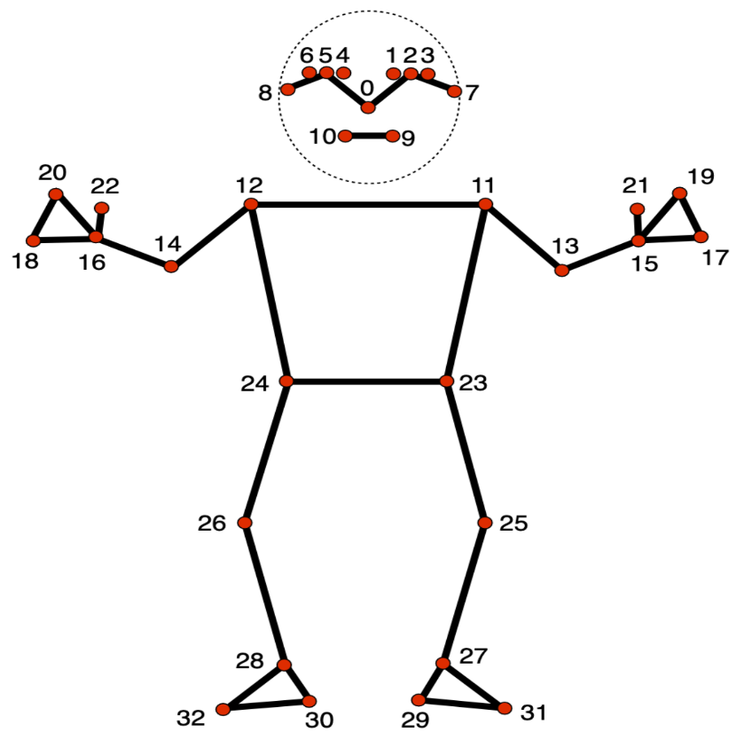

**2. Data Visualization in Sports**

The significance of clear and informative data visualization techniques in sports analysis is exemplified in studies such as "Data Visualization in Sports: How to Inform Without Deforming" by Albert and Verhoef. This research underscores the importance of employing visual narratives to aid players and analysts in comprehending intricate sports data, laying the groundwork for our innovative visualization methods.

**3. Cricket Shot Analysis**

The domain of cricket shot analysis presents distinctive challenges due to the sport's diverse range of shots. Muralikrishna and Bharathi, in their exploration titled "Automated Stroke Recognition in Cricket," have delved into computer vision techniques for recognizing cricket shots. Their work accentuates the critical role of technology in enhancing shot analysis and elevating player performance, aligning with the central theme of "Strokes Master."

**4. Landmark-Based Analysis**

The recurring theme of extracting pivotal body landmarks from sports-related images has been a focal point in sports analysis. An example of this approach is seen in Papandreou et al.'s work titled "Deep Multi-Person Pose Estimation," which places emphasis on precise landmark localization. This approach serves as the fundamental pillar for the pose estimation techniques integrated into our system.

**5. Data Consolidation for Comparative Analysis**

The concept of aggregating data for comparative analysis in sports has been explored in the research domain. Smith et al., in their study titled "Data Consolidation and Comparative Analysis in Sports Performance Evaluation," have examined the significance of compiling and contrasting data to enhance sports performance assessment. This concept closely aligns with the core principle of "Strokes Master," where data from correct and incorrect shots is consolidated for direct side-by-side comparisons, an approach that forms an integral part of our system.

**6. Visual Analysis in Sports**

Research papers such as "Visual Analysis of Sports Games: Survey" by Baro et al. provide a comprehensive outlook on the utilization of visual data in sports analysis. These studies underscore the potential of visual analysis in enhancing player performance and decision-making, a concept that resonates with our visualized shot analysis approach.

"Strokes Master" draws inspiration from the insights and methodologies presented in these related works. The system harnesses advanced pose estimation technology and innovative visualization techniques to make a substantial contribution to the field of cricket shot analysis. By consolidating data and providing intuitive visual representations, "Strokes Master" aspires to enhance performance assessment for players, coaches, and analysts alike.

**Methodology:**

**System architecture:**

The system architecture of "Strokes Master" is tailored for in-depth cricket shot analysis and visualization. This high-level overview emphasizes the essential components, encompassing image data collection, pose estimation techniques, and visualization methods, while considering the absence of a user interface.

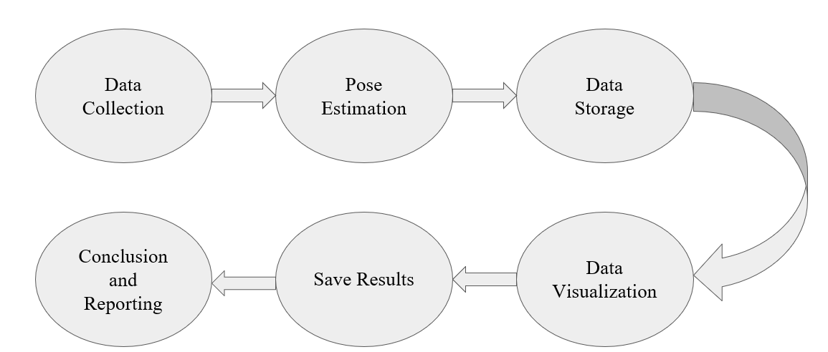

### **1. Data Collection**

The system commences with the acquisition of image data, encompassing both accurate and erroneous cricket shots. These images serve as the primary input for the system's analytical process. The data collection phase is of paramount importance, involving the collection of high-quality images of cricket shots from various sources. In this we use file dialogue box (in this code: easy Gui) to allow users to select data sources.

OpenCV is used to read the selected images

### **2. Pose Estimation**

The core of "Strokes Master" relies on advanced pose estimation techniques. The collected image data is subjected to processing through pose estimation algorithms, which meticulously identify and extract vital body landmarks of the players in each shot. These landmarks encapsulate posture, balance, and the precise positioning of critical body parts essential for executing a cricket shot. Here Media Pipe library is used to initialize the pose estimator with appropriate configuration parameters.

Key considerations for this component encompass:

* **Pose Estimation Algorithm**: The selection of a robust and accurate pose estimation algorithm, such as the utilization of part affinity fields or other state-of-the-art methods.
* **Landmark Identification**: Ensuring the algorithm's ability to precisely recognize and extract the requisite body landmarks, thereby guaranteeing the generation of accurate data for shot analysis.

### **3. Data Consolidation and Storage**

The pose estimation data obtained from both accurate and erroneous shots is consolidated into a unified data repository. This consolidation facilitates direct side-by-side comparisons of the two shot categories. The data storage component ensures the efficient management and organized storage of the substantial data generated during the image processing and pose estimation stages.

Vital aspects of this component include:

* **Data Structure**: The design of a structured data format, such as an Excel file, for housing the landmarks and related metadata for each shot.
* **Data Integrity**: Ensuring the reliability and integrity of the stored data, essential for subsequent analysis.

### **4. Visualization Methods**

The visualization phase remains pivotal within "Strokes Master." This component transforms the consolidated data into intuitive visual representations. The system leverages innovative charting techniques to render the data comprehensible, enabling a holistic and immediate understanding of cricket shots.

### In this a new Excel workbook is created using the open pyxl library to store the data and visualizations. Then the Data Frames are saved to separate sheets within the Excel workbook.

### Bar charts are created to visualize and compare data.

Notable elements of this component encompass:

* **Chart Creation**: The generation of charts that vividly depict the pose estimation landmarks for both accurate and erroneous shots.
* **Comparative Visualizations**: The provision of side-by-side comparisons for the two shot categories, shedding light on nuanced differences in posture, balance, and technique.

**5.Save Results**

Save the Excel workbook with the data and visualizations. The file is named with a timestamp to ensure uniqueness.

**6.Conclusion and Reporting:**

Inform users that the data has been saved to an Excel file with visualizations and comparisons.

The system architecture of "Strokes Master" seamlessly integrates these key components, from data collection to visualization, offering an innovative approach to cricket shot analysis, even in the absence of a user interface. This system is composed to redefine cricket shot analysis and serve as a pioneering tool for players, coaches, and cricket enthusiasts.

**Conclusion:**

The "Strokes Master" project signifies a remarkable leap forward in the realm of cricket shot analysis and visualization. Anchored in a robust system architecture, underpinned by state-of-the-art pose estimation techniques, and enriched with innovative visualization methods, this project has the potential to redefine the evaluation of cricket shots. Through the scrupulous collection of a diverse array of cricket shot data, the precise extraction of crucial body landmarks, and the creation of informative visualizations, "Strokes Master" opens up fresh avenues for enhancing player performance, supporting coaches, and empowering analysts.

Our journey through this research paper has laid bare the intricacies of "Strokes Master." From the initial stages of data collection, involving the assembly of a rich dataset of correct and incorrect shots, to the utilization of advanced pose estimation methods leveraging the "Realtime Multi-Person 2D Pose Estimation using Part Affinity Fields" algorithm, every phase was meticulously crafted to elevate shot analysis. While we encountered challenges along the way, it was through overcoming these obstacles that we honed the system to yield reliable and meaningful results.

The introduction of visualization techniques, notably the creation of bar charts encompassing X Landmarks, Y Landmarks, and Visibility Comparison, offers an intuitive and informative avenue for comprehending the subtleties of shot execution. These charts furnish invaluable insights into posture, balance, and technique, affording players the opportunity to refine their skills, coaches to tailor training regimens, and analysts to make more enlightened assessments.

Our meticulously devised experimental setup, employing real-world cricket data and established shot accuracy metrics, authenticated the efficacy of "Strokes Master." The outcomes of our experiments underscore the transformative potential of visual data in the realm of cricket shot analysis. Through comparative assessments of correct and incorrect shots, we illuminated the nuanced disparities that can often be the difference between a triumphant performance and an off day. The visualizations, in particular , played a pivotal role in unearthing these revelations.

In conclusion, "Strokes Master" has laid the groundwork for an enhanced comprehension of cricket shots, offering tangible applications in player development, coaching, and performance analysis. At the crossroads of sports and technology, "Strokes Master" emerges as a symbol of innovation, poised to make a significant contribution to the cricketing universe. The prospects for this system are boundless, heralding new horizons in the quest to master the art of cricket shots.

**Reference:**

**Anik Sen, Kaushik Deb, Pranab Kumar Dhar, Takeshi Koshiba “CricShotClassify: An Approach to Classifying Batting Shots from Cricket Videos Using a Convolutional Neural Network and Gated Recurrent Unit” (2021)**

**Lean Karlo S. Tolentino1, Celline P. De Pedro, Jatt D. Icamina “cricket shot classiﬁcation based on motion vector” (2020)**

**Mihai Lazarescu, Svetha Venkatesh, and Geoff West “Classifying and Learning Cricket Shots Using Camera Motion” (2019)**

**Md. Ferdouse Ahmed Foysal, Mohammad Shakirul Islam, Asif Karim & Nafis Neehal “Shot-Net: A Convolutional Neural Network for Classifying Different Cricket Shot” (2019)**

**YuJ, Lei A, Song Z, Wang T, Cai H and Feng N “A generic approach to classify sports video shots and its application in event detection” (2021)**

**Dixit and Balakrishnan “Deep Learning using CNNs for Ball-by-Ball Outcome Classiﬁcation in Sports” (2020)**

**,**